**Spring REST using Spring Boot 3 Hands-on**

**Name : Udit Bhargava**

**Superset Id : 6386801**

**Exercise 1: Create a Spring Web Project using Maven**

**CODE :**

**Pom.xml :**

<?xml version="1.0" encoding="UTF-8"?>  
<project xmlns="http://maven.apache.org/POM/4.0.0" xmlns:xsi="http://www.w3.org/2001/XMLSchema-instance"  
 xsi:schemaLocation="http://maven.apache.org/POM/4.0.0 https://maven.apache.org/xsd/maven-4.0.0.xsd">  
 <modelVersion>4.0.0</modelVersion>  
 <parent>  
 <groupId>org.springframework.boot</groupId>  
 <artifactId>spring-boot-starter-parent</artifactId>  
 <version>3.5.3</version>  
 <relativePath/> <!-- lookup parent from repository -->  
 </parent>  
 <groupId>com.cognizant</groupId>  
 <artifactId>spring-learn</artifactId>  
 <version>0.0.1-SNAPSHOT</version>  
 <name>spring-learn</name>  
 <description>Demo project for Spring Boot</description>  
 <url/>  
 <licenses>  
 <license/>  
 </licenses>  
 <developers>  
 <developer/>  
 </developers>  
 <scm>  
 <connection/>  
 <developerConnection/>  
 <tag/>  
 <url/>  
 </scm>  
 <properties>  
 <java.version>21</java.version>  
 </properties>  
 <dependencies>  
 <dependency>  
 <groupId>org.springframework.boot</groupId>  
 <artifactId>spring-boot-starter-web</artifactId>  
 </dependency>  
  
 <dependency>  
 <groupId>org.springframework.boot</groupId>  
 <artifactId>spring-boot-devtools</artifactId>  
 <scope>runtime</scope>  
 <optional>true</optional>  
 </dependency>  
 <dependency>  
 <groupId>org.springframework.boot</groupId>  
 <artifactId>spring-boot-starter-test</artifactId>  
 <scope>test</scope>  
 </dependency>  
 </dependencies>  
  
 <build>  
 <plugins>  
 <plugin>  
 <groupId>org.springframework.boot</groupId>  
 <artifactId>spring-boot-maven-plugin</artifactId>  
 </plugin>  
 </plugins>  
 </build>  
  
</project>

**SpringLearnApplication.java :**

package com.cognizant.spring_learn;  
  
import org.slf4j.Logger;  
import org.slf4j.LoggerFactory;  
import org.springframework.boot.SpringApplication;  
import org.springframework.boot.autoconfigure.SpringBootApplication;  
  
@SpringBootApplication  
public class SpringLearnApplication {  
  
 private static final Logger *LOGGER* = LoggerFactory.*getLogger*(SpringLearnApplication.class);  
  
 public static void main(String[] args) {  
 SpringApplication.*run*(SpringLearnApplication.class, args);  
 *LOGGER*.info("START");  
  
 }  
}

**Output :**

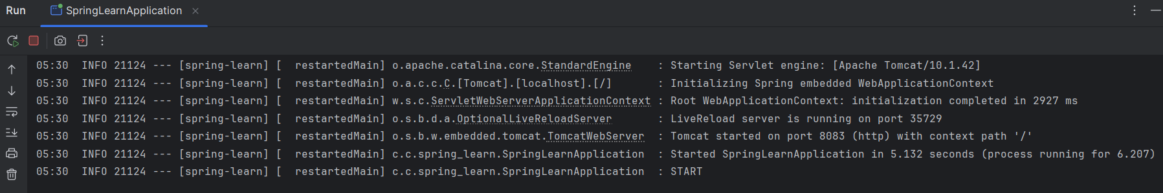

**Exercise 2: Spring Core – Load Country from Spring Configuration XML**

**CODE :**

**Country.xml :**

<?xml version="1.0" encoding="UTF-8"?>  
<beans xmlns="http://www.springframework.org/schema/beans"  
 xmlns:xsi="http://www.w3.org/2001/XMLSchema-instance"  
 xsi:schemaLocation="http://www.springframework.org/schema/beans  
 http://www.springframework.org/schema/beans/spring-beans.xsd">  
  
 <bean id="country" class="com.cognizant.spring_learn.Country">  
 <property name="code" value="IN"/>  
 <property name="name" value="India"/>  
 </bean>  
  
</beans>

**Country.java :**

package com.cognizant.spring_learn;  
  
import org.slf4j.Logger;  
import org.slf4j.LoggerFactory;  
  
  
public class Country {  
  
 private static final Logger *LOGGER* = LoggerFactory.*getLogger*(Country.class);  
  
 private String code;  
 private String name;  
  
 public Country(){  
 *LOGGER*.debug("Inside Country Constructor");  
 }  
  
 public String getCode(){  
 *LOGGER*.debug("Inside getCode()");  
 return code;  
 }  
  
 public void setCode(String code) {  
 *LOGGER*.debug("Inside setCode()");  
 this.code = code;  
 }  
  
 public String getName() {  
 *LOGGER*.debug("Inside getName()");  
 return name;  
 }  
  
 public void setName(String name) {  
 *LOGGER*.debug("Inside setName()");  
 this.name = name;  
 }  
  
 @Override  
 public String toString() {  
 return "Country [code=" + code + ", name=" + name + "]";  
 }  
}

**SpringLearnApplication.java :**

package com.cognizant.spring_learn;  
  
import org.slf4j.Logger;  
import org.slf4j.LoggerFactory;  
import org.springframework.boot.SpringApplication;  
import org.springframework.boot.autoconfigure.SpringBootApplication;  
import org.springframework.context.ApplicationContext;  
import org.springframework.context.support.ClassPathXmlApplicationContext;  
  
@SpringBootApplication  
public class SpringLearnApplication {  
  
 private static final Logger *LOGGER* = LoggerFactory.*getLogger*(SpringLearnApplication.class);  
  
 public static void main(String[] args) {  
 SpringApplication.*run*(SpringLearnApplication.class, args);  
 *LOGGER*.info("START");  
 *displayCountry*();  
 *LOGGER*.info("END");  
 }  
  
 public static void displayCountry() {  
 ApplicationContext context = new ClassPathXmlApplicationContext("country.xml");  
 Country country = context.getBean("country", Country.class);  
 *LOGGER*.debug("Country : {}", country.toString());  
 }  
}

**Output :**

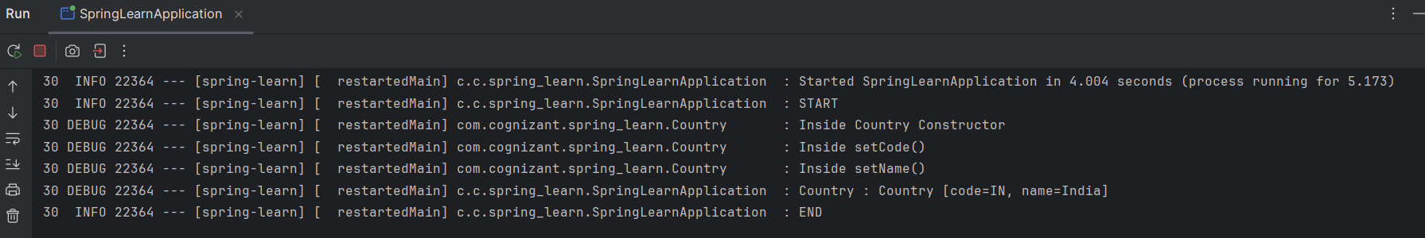

**Exercise 3: Hello World RESTful Web Service**

**CODE :**

**HelloController.java :**

package com.cognizant.spring_learn.controller;  
  
import org.slf4j.Logger;  
import org.slf4j.LoggerFactory;  
import org.springframework.web.bind.annotation.GetMapping;  
import org.springframework.web.bind.annotation.RestController;  
  
@RestController  
public class HelloController {  
  
 private static final Logger *log* = LoggerFactory.*getLogger*(HelloController.class);  
  
 @GetMapping("/hello")  
 public String sayHello(){  
 *log*.info("START");  
 String s = "Hello World!!";  
 *log*.info("END");  
  
 return s;  
 }  
}

**SpringLearnApplication.java :**

package com.cognizant.spring_learn;  
  
import org.slf4j.Logger;  
import org.slf4j.LoggerFactory;  
import org.springframework.boot.SpringApplication;  
import org.springframework.boot.autoconfigure.SpringBootApplication;  
  
@SpringBootApplication  
public class SpringLearnApplication {  
  
 private static final Logger *LOGGER* = LoggerFactory.*getLogger*(SpringLearnApplication.class);  
  
 public static void main(String[] args) {  
 SpringApplication.*run*(SpringLearnApplication.class, args);  
 *LOGGER*.info("START");  
 *LOGGER*.info("END");  
 }  
}

**Output :**

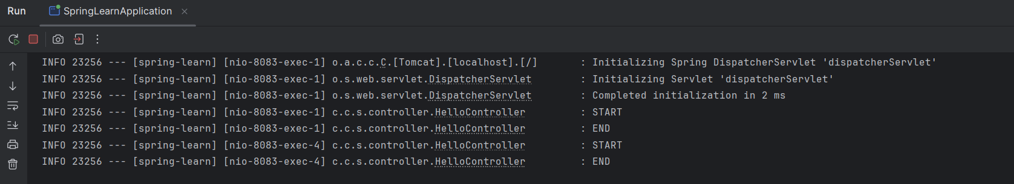

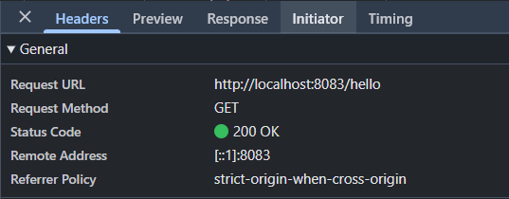

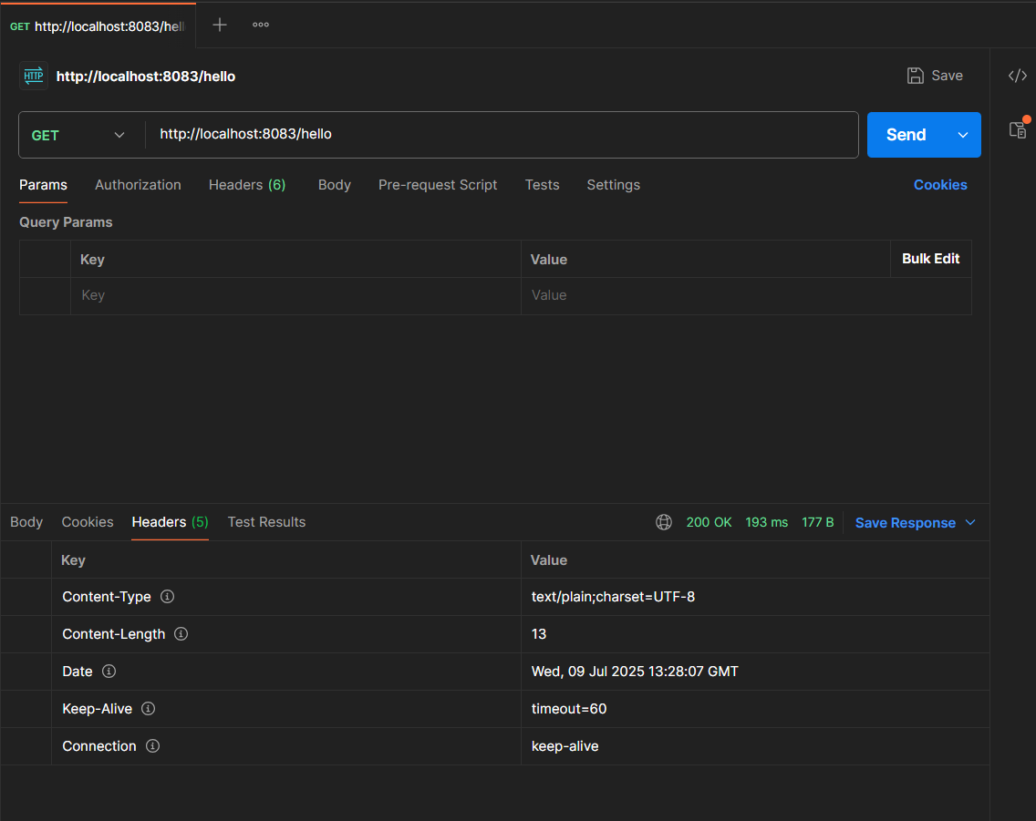

**Exercise 4: REST - Country Web Service**

**CODE :**

**country.xml :**

<?xml version="1.0" encoding="UTF-8"?>  
<beans xmlns="http://www.springframework.org/schema/beans"  
 xmlns:xsi="http://www.w3.org/2001/XMLSchema-instance"  
 xsi:schemaLocation="http://www.springframework.org/schema/beans  
 http://www.springframework.org/schema/beans/spring-beans.xsd">  
  
 <bean id="country" class="com.cognizant.spring_learn.Country">  
 <property name="code" value="IN"/>  
 <property name="name" value="India"/>  
 </bean>  
  
</beans>

**Country.java :**

package com.cognizant.spring_learn;  
  
import org.slf4j.Logger;  
import org.slf4j.LoggerFactory;  
  
  
public class Country {  
  
 private static final Logger *LOGGER* = LoggerFactory.*getLogger*(Country.class);  
  
 private String code;  
 private String name;  
  
 public Country(){  
 *LOGGER*.debug("Inside Country Constructor");  
 }  
  
 public String getCode(){  
 *LOGGER*.debug("Inside getCode()");  
 return code;  
 }  
  
 public void setCode(String code) {  
 *LOGGER*.debug("Inside setCode()");  
 this.code = code;  
 }  
  
 public String getName() {  
 *LOGGER*.debug("Inside getName()");  
 return name;  
 }  
  
 public void setName(String name) {  
 *LOGGER*.debug("Inside setName()");  
 this.name = name;  
 }  
  
 @Override  
 public String toString() {  
 return "Country [code=" + code + ", name=" + name + "]";  
 }  
}

**CountryController.java :**

package com.cognizant.spring_learn.controller;  
  
import com.cognizant.spring_learn.Country;  
import org.slf4j.Logger;  
import org.slf4j.LoggerFactory;  
import org.springframework.context.ApplicationContext;  
import org.springframework.context.support.ClassPathXmlApplicationContext;  
import org.springframework.web.bind.annotation.RequestMapping;  
import org.springframework.web.bind.annotation.RestController;  
  
@RestController  
public class CountryController {  
  
 private static final Logger *LOGGER* = LoggerFactory.*getLogger*(CountryController.class);  
  
 @RequestMapping("/country")  
 public Country getCountryIndia() {  
 *LOGGER*.info("START");  
 ApplicationContext context = new ClassPathXmlApplicationContext("country.xml");  
 Country country = context.getBean("country", Country.class);  
 *LOGGER*.info("END");  
 return country;  
 }  
}

**SpringLearnApplication.java :**

package com.cognizant.spring_learn;  
  
import org.slf4j.Logger;  
import org.slf4j.LoggerFactory;  
import org.springframework.boot.SpringApplication;  
import org.springframework.boot.autoconfigure.SpringBootApplication;  
  
@SpringBootApplication  
public class SpringLearnApplication {  
  
 private static final Logger *LOGGER* = LoggerFactory.*getLogger*(SpringLearnApplication.class);  
  
 public static void main(String[] args) {  
 SpringApplication.*run*(SpringLearnApplication.class, args);  
 *LOGGER*.info("START");  
 *LOGGER*.info("END");  
 }  
}

**Output :**

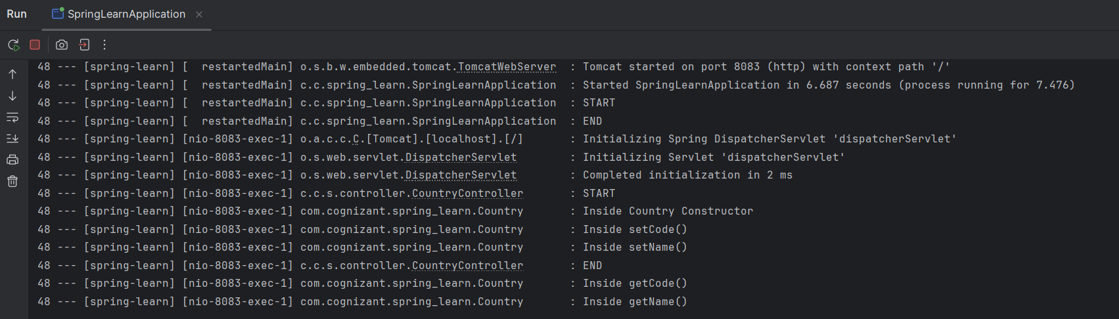

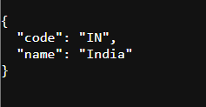

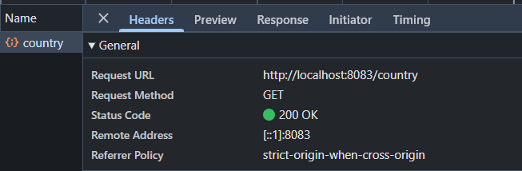

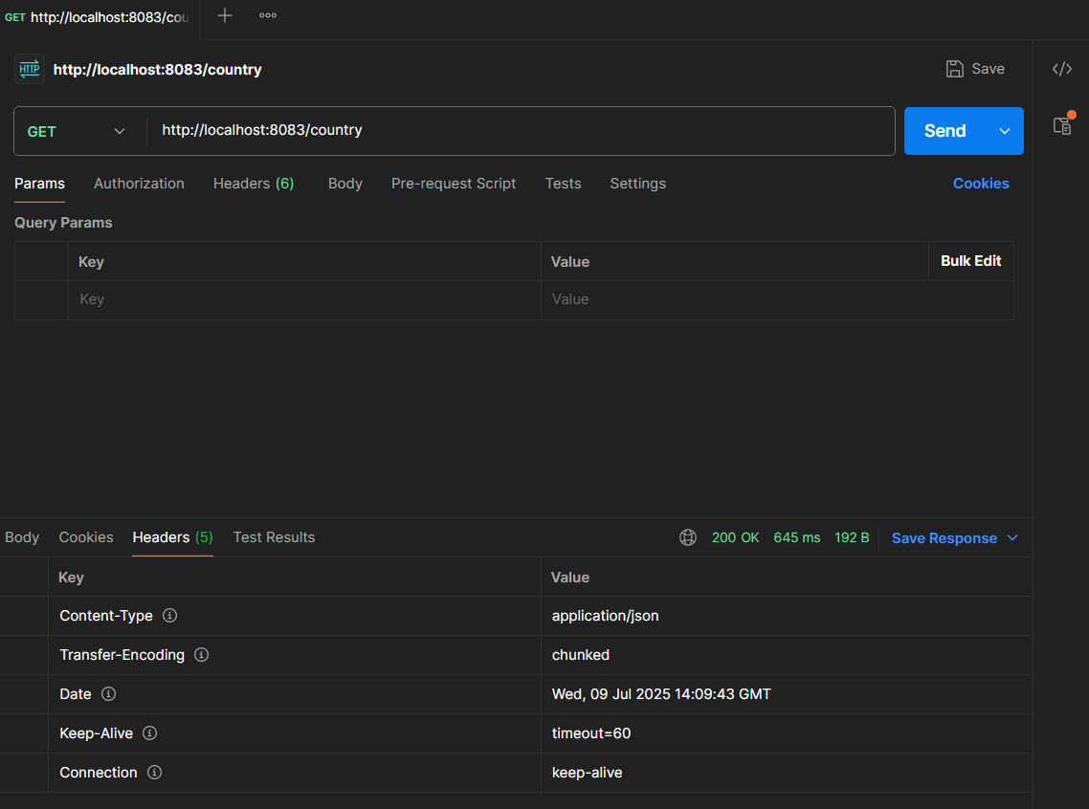

**Exercise 5: REST - Get country based on country code**

**CODE :**

**country.xml :**

<?xml version="1.0" encoding="UTF-8"?>  
<beans xmlns="http://www.springframework.org/schema/beans"  
 xmlns:xsi="http://www.w3.org/2001/XMLSchema-instance"  
 xsi:schemaLocation="http://www.springframework.org/schema/beans  
 http://www.springframework.org/schema/beans/spring-beans.xsd">  
  
 <bean id="in" class="com.cognizant.spring_learn.Country">  
 <property name="code" value="IN"/>  
 <property name="name" value="India"/>  
 </bean>  
  
 <bean id="us" class="com.cognizant.spring_learn.Country">  
 <property name="code" value="US"/>  
 <property name="name" value="United States"/>  
 </bean>  
  
 <bean id="jp" class="com.cognizant.spring_learn.Country">  
 <property name="code" value="JP"/>  
 <property name="name" value="Japan"/>  
 </bean>  
  
 <bean id="de" class="com.cognizant.spring_learn.Country">  
 <property name="code" value="DE"/>  
 <property name="name" value="Germany"/>  
 </bean>  
  
 <bean id="countryList" class="java.util.ArrayList">  
 <constructor-arg>  
 <list>  
 <ref bean="in" />  
 <ref bean="us" />  
 <ref bean="jp" />  
 <ref bean="de" />  
 </list>  
 </constructor-arg>  
 </bean>  
  
</beans>

**Country.java :**

package com.cognizant.spring_learn;  
  
import org.slf4j.Logger;  
import org.slf4j.LoggerFactory;  
  
  
public class Country {  
  
 private static final Logger *LOGGER* = LoggerFactory.*getLogger*(Country.class);  
  
 private String code;  
 private String name;  
  
 public Country(){  
 *LOGGER*.debug("Inside Country Constructor");  
 }  
  
 public String getCode(){  
 *LOGGER*.debug("Inside getCode()");  
 return code;  
 }  
  
 public void setCode(String code) {  
 *LOGGER*.debug("Inside setCode()");  
 this.code = code;  
 }  
  
 public String getName() {  
 *LOGGER*.debug("Inside getName()");  
 return name;  
 }  
  
 public void setName(String name) {  
 *LOGGER*.debug("Inside setName()");  
 this.name = name;  
 }  
  
 @Override  
 public String toString() {  
 return "Country [code=" + code + ", name=" + name + "]";  
 }  
}

**CountryService.java :**

package com.cognizant.spring_learn.service;  
  
import com.cognizant.spring_learn.Country;  
import org.springframework.context.ApplicationContext;  
import org.springframework.context.support.ClassPathXmlApplicationContext;  
import org.springframework.stereotype.Service;  
  
import java.util.List;  
  
@Service  
public class CountryService {  
  
 public Country getCountry(String code){  
 ApplicationContext context = new ClassPathXmlApplicationContext("country.xml");  
 List<Country> countries = context.getBean("countryList", List.class);  
  
 return countries.stream()  
 .filter(c -> c.getCode().equalsIgnoreCase(code))  
 .findFirst()  
 .orElse(null);  
 }  
}

**CountryController.java :**

package com.cognizant.spring_learn.controller;  
  
import com.cognizant.spring_learn.Country;  
import com.cognizant.spring_learn.service.CountryService;  
import org.slf4j.Logger;  
import org.slf4j.LoggerFactory;  
import org.springframework.beans.factory.annotation.Autowired;  
import org.springframework.context.ApplicationContext;  
import org.springframework.context.support.ClassPathXmlApplicationContext;  
import org.springframework.web.bind.annotation.GetMapping;  
import org.springframework.web.bind.annotation.PathVariable;  
import org.springframework.web.bind.annotation.RequestMapping;  
import org.springframework.web.bind.annotation.RestController;  
  
import java.util.List;  
  
@RestController  
public class CountryController {  
  
 private static final Logger *LOGGER* = LoggerFactory.*getLogger*(CountryController.class);  
  
 @Autowired  
 private CountryService countryService;  
  
 @GetMapping("/country/{code}")  
 public Country getCountry(@PathVariable String code) {  
 *LOGGER*.info("START");  
 Country country = countryService.getCountry(code);  
 *LOGGER*.info("END");  
 return country;  
 }  
  
 @RequestMapping("/countries")  
 public List<Country> getAllCountries() {  
 *LOGGER*.info("START");  
 ApplicationContext context = new ClassPathXmlApplicationContext("country.xml");  
 List<Country> countries = context.getBean("countryList", List.class);  
 *LOGGER*.info("END");  
 return countries;  
 }  
}

**SpringLearnApplication.java :**

package com.cognizant.spring_learn;  
  
import org.slf4j.Logger;  
import org.slf4j.LoggerFactory;  
import org.springframework.boot.SpringApplication;  
import org.springframework.boot.autoconfigure.SpringBootApplication;  
  
@SpringBootApplication  
public class SpringLearnApplication {  
  
 private static final Logger *LOGGER* = LoggerFactory.*getLogger*(SpringLearnApplication.class);  
  
 public static void main(String[] args) {  
 SpringApplication.*run*(SpringLearnApplication.class, args);  
 *LOGGER*.info("START");  
 *LOGGER*.info("END");  
 }  
}

**Output :**



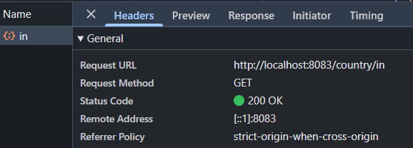

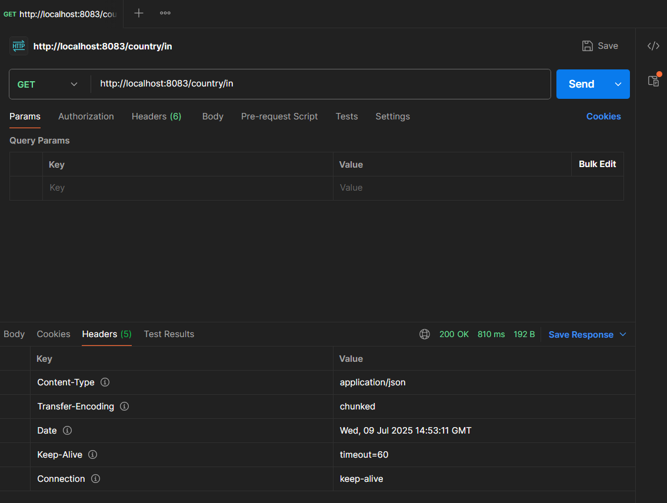

**Exercise 6: Create authentication service that returns JWT**

**CODE :**

**pom.xml :**

<?xml version="1.0" encoding="UTF-8"?>  
<project xmlns="http://maven.apache.org/POM/4.0.0" xmlns:xsi="http://www.w3.org/2001/XMLSchema-instance"  
 xsi:schemaLocation="http://maven.apache.org/POM/4.0.0 https://maven.apache.org/xsd/maven-4.0.0.xsd">  
 <modelVersion>4.0.0</modelVersion>  
 <parent>  
 <groupId>org.springframework.boot</groupId>  
 <artifactId>spring-boot-starter-parent</artifactId>  
 <!-- <version>3.5.3</version> -->  
 <version>2.6.6</version>  
 <relativePath/> <!-- lookup parent from repository -->  
 </parent>  
 <groupId>com.cognizant</groupId>  
 <artifactId>springJwt</artifactId>  
 <version>0.0.1-SNAPSHOT</version>  
 <name>springJwi</name>  
 <description>Demo project for Spring Boot</description>  
 <url/>  
 <licenses>  
 <license/>  
 </licenses>  
 <developers>  
 <developer/>  
 </developers>  
 <scm>  
 <connection/>  
 <developerConnection/>  
 <tag/>  
 <url/>  
 </scm>  
 <properties>  
 <java.version>17</java.version>  
 </properties>  
 <dependencies>  
 <dependency>  
 <groupId>org.springframework.boot</groupId>  
 <artifactId>spring-boot-starter-security</artifactId>  
 </dependency>  
 <dependency>  
 <groupId>org.springframework.boot</groupId>  
 <artifactId>spring-boot-starter-web</artifactId>  
 </dependency>  
  
 <dependency>  
 <groupId>org.springframework.boot</groupId>  
 <artifactId>spring-boot-devtools</artifactId>  
 <scope>runtime</scope>  
 <optional>true</optional>  
 </dependency>  
 <dependency>  
 <groupId>org.springframework.boot</groupId>  
 <artifactId>spring-boot-starter-test</artifactId>  
 <scope>test</scope>  
 </dependency>  
 <dependency>  
 <groupId>org.springframework.security</groupId>  
 <artifactId>spring-security-test</artifactId>  
 <scope>test</scope>  
 </dependency>  
 <dependency>  
 <groupId>io.jsonwebtoken</groupId>  
 <artifactId>jjwt-api</artifactId>  
 <version>0.11.5</version>  
 </dependency>  
 <dependency>  
 <groupId>io.jsonwebtoken</groupId>  
 <artifactId>jjwt-impl</artifactId>  
 <version>0.11.5</version>  
 <scope>runtime</scope>  
 </dependency>  
 <dependency>  
 <groupId>io.jsonwebtoken</groupId>  
 <artifactId>jjwt-jackson</artifactId>  
 <version>0.11.5</version>  
 <scope>runtime</scope>  
 </dependency>  
 <dependency>  
 <groupId>org.slf4j</groupId>  
 <artifactId>slf4j-api</artifactId>  
 <version>1.7.36</version>  
 </dependency>  
 <dependency>  
 <groupId>ch.qos.logback</groupId>  
 <artifactId>logback-classic</artifactId>  
 <version>1.2.10</version>  
 </dependency>  
 <dependency>  
 <groupId>org.projectlombok</groupId>  
 <artifactId>lombok</artifactId>  
 <version>1.18.30</version>  
 <scope>provided</scope>  
 </dependency>  
 <dependency>  
 <groupId>javax.xml.bind</groupId>  
 <artifactId>jaxb-api</artifactId>  
 <version>2.3.1</version>  
 </dependency>  
 </dependencies>  
  
 <build>  
 <plugins>  
 <plugin>  
 <groupId>org.springframework.boot</groupId>  
 <artifactId>spring-boot-maven-plugin</artifactId>  
 </plugin>  
 </plugins>  
 </build>  
  
</project>

**AuthenticationController.java :**

package com.cognizant.springJwt.controller;  
  
import io.jsonwebtoken.JwtBuilder;  
import io.jsonwebtoken.Jwts;  
import io.jsonwebtoken.SignatureAlgorithm;  
import lombok.extern.slf4j.Slf4j;  
import org.slf4j.Logger;  
import org.springframework.web.bind.annotation.*;  
  
import java.util.*;  
  
@RestController  
@Slf4j  
public class AuthenticationController {  
  
 private static final Logger *log* = org.slf4j.LoggerFactory.*getLogger*(AuthenticationController.class);  
 private static final String *SECRET_KEY* = "MyVerySecureSecretKeyThatIsLong123!";  
 @GetMapping("/authenticate")  
 public Map<String, String> authenticate(@RequestHeader("Authorization") String authHeader) {  
 *log*.info("START - /authenticate");  
 *log*.debug("Authorization Header: {}", authHeader);  
  
 String user = getUser(authHeader);  
 String token = generateJwt(user);  
  
 Map<String, String> map = new HashMap<>();  
 map.put("token", token);  
  
 *log*.info("END - /authenticate");  
 return map;  
 }  
  
 private String getUser(String authHeader) {  
 *log*.debug("Extracting user from authHeader...");  
  
 String encodedCredentials = authHeader.replace("Basic ", "");  
 byte[] decodedBytes = Base64.*getDecoder*().decode(encodedCredentials);  
 String decodedString = new String(decodedBytes); // "user:pwd"  
  
 String username = decodedString.split(":")[0];  
 *log*.debug("Decoded username: {}", username);  
  
 return username;  
 }  
  
  
 private String generateJwt(String user) {  
 JwtBuilder builder = Jwts.*builder*()  
 .setSubject(user)  
 .setIssuedAt(new Date())  
 .setExpiration(new Date(System.*currentTimeMillis*() + 1200000)) // 20 mins  
 .signWith(SignatureAlgorithm.*HS256*, *SECRET_KEY*.getBytes()); // Use byte[] here  
  
 String token = builder.compact();  
 *log*.debug("Generated JWT: {}", token);  
 return token;  
 }  
}

**SecurityConfig.java :**

package com.cognizant.springJwt.security;  
  
import org.springframework.context.annotation.Configuration;  
import org.springframework.security.config.annotation.authentication.builders.AuthenticationManagerBuilder;  
import org.springframework.security.config.annotation.web.builders.HttpSecurity;  
import org.springframework.security.config.annotation.web.configuration.*;  
  
@Configuration  
@EnableWebSecurity  
public class SecurityConfig extends WebSecurityConfigurerAdapter {  
  
 @Override  
 protected void configure(AuthenticationManagerBuilder auth) throws Exception {  
 auth.inMemoryAuthentication()  
 .withUser("user").password("{noop}pwd").roles("USER")  
 .and()  
 .withUser("admin").password("{noop}adminpwd").roles("ADMIN");  
 }  
  
 @Override  
 protected void configure(HttpSecurity http) throws Exception {  
 http.csrf().disable() // for simplicity  
 .authorizeRequests()  
 .antMatchers("/authenticate").hasAnyRole("USER", "ADMIN")  
 .anyRequest().authenticated()  
 .and()  
 .httpBasic();  
 }  
}

**Output :**

